**SE 102.3 – Web Based Application Development**

**Tutorial**

1. Write HTML codes to create the following tables

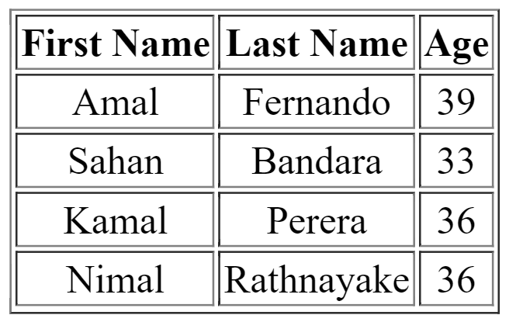

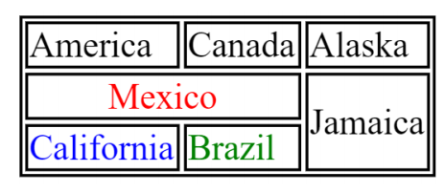

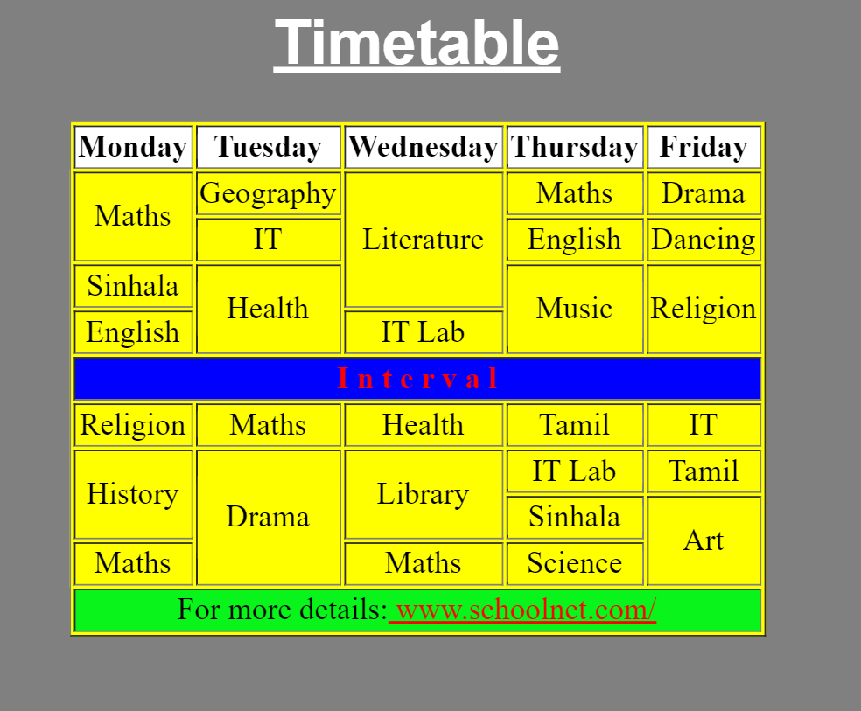

**Answers**

<html>

<head>

<title>Table</title>

</head>

<body>

<table border="1" width="300" height="50" style="Text-align:center">

<tr>

<th>First Name</th>

<th>Last Name</th>

<th>Age</th>

</tr>

<tr>

<td>Amal</td>

<td>Fernando</td>

<td>39</td>

</tr>

<tr>

<td>Sahan</td>

<td>Bandara</td>

<td>33</td>

</tr>

<tr>

<td>Kamal</td>

<td>Perera</td>

<td>36</td>

</tr>

<tr>

<td>Nimal</td>

<td>Rathnayake</td>

<td>36</td>

</tr>

</table>

</body>

</html>

…………………………………………………………………………………………………………………………………………………….

<html>

<head>

<title>Table</title>

</head>

<body>

<table border="1" width="300" height="50" style="text-align:center">

<tr>

<td>America</td>

<td>Canada</td>

<td>Alaska</td>

</tr>

<tr>

<td colspan="2" style="color:red">Mexico</td>

<td rowspan="2">Jamaica</td>

</tr>

<tr>

<td style="color:blue">Califonia</td>

<td style="color:green">Brazil</td>

</tr>

</table>

</body>

</html>

…………………………………………………………………………………………………………………………………………………

<!DOCTYPE html>

<html>

<head>

<title>Hello, World!</title>

</head>

<body bgcolor="grey">

<h1 style="color:white; font-family:arial"><u><center>Timetable</center></u></h1>

<table border="1" width="300" height="50" bgcolor="Yellow" style="Text-align:center" align="center" >

<tr bgcolor="white">

<th>Monday</th>

<th>Tuesday</th>

<th>Wednesday</th>

<th>Thursday</th>

<th>Friday</th>

</tr>

<tr>

<td rowspan="2">Maths</td>

<td>Geography</td>

<td rowspan="3">Literature</td>

<td>Maths</td>

<td>Drama</td>

</tr>

<tr>

<td>IT</td>

<td>English</td>

<td>Dancing</td>

</tr>

<tr>

<td>Sinhala</td>

<td rowspan="2">Music</td>

<td rowspan="2">Religion</td>

</tr>

<tr>

<td>English</td>

<td>IT Lab</td>

</tr>

<tr>

<td colspan="5" bgcolor="Blue" style="color:red">Interval</td>

</tr>

<tr>

<td>Religion</td>

<td>Maths</td>

<td>Health</td>

<td>Tamil</td>

<td>IT</td>

</tr>

<tr>

<td rowspan="2">History</td>

<td rowspan="3">Drama</td>

<td rowspan="2">Library</td>

<td>IT Lab</td>

<td>Tamil</td>

</tr>

<tr>

<td>Sinhala</td>

<td rowspan="2">Art</td>

</tr>

<tr>

<td>Maths</td>

<td>Maths</td>

<td>Science</td>

</tr>

<tr bgcolor="lightgreen">

<td colspan="5">For more details: <font color="red"><u>www.schoolnet.com/</u></font></details></td>

</tr>

</table>

</body>

</html>